Abstract— This paper summarizes some of the results of a simulation project proposed by the professor Chi-Seng Lam for his course Flexible Alternative Current Transmission System at the University of Macau. Using the software PSCAD is possible to create some systems to a better understanding of Power Quality and power filters to control it.
Simulation Project – Current Quality
DIOGO MARTINS, Student Member IEEE, University of Macau

Index Terms— FACTS, D-FACTS, Power Quality, Current Quality Problems, Active Power Filters, Passive Power Filters, PWM Inverters, Instantaneous Reactive Power Theory.

Current Quality Problems
One of the main goals of the electric utility industry is to provide the consumers with a reliable and uninterrupted supply of electricity. Electricity supply is one of the essential bases for the support of industrial, commercial, and residential applications. There are some solutions to resolve the power quality problems. On the last years, the growth of non-linear loads, such as diodes, thyristors rectifiers, and cycloconverters draw non-sinusoidal currents into the power system, contributing to the degradation of Power Quality in utility or Industrial Power System [1].
Electronic and Power equipment has become really sensitive. Electrical companies become more afflicted because of the production and consumption reason. Increasingly, grid discontinuities are avoided due to the use and need of energy in society. On the domestic market, electricity is considered a basic right, which should be always present. On the other hand, equipment when are badly used by the consumer, and some of the modern electronic devices are sensitive to voltages disturbances. All components of the grid, together, produce multiples disturbances of the current which will increase the harmonic [2].
Current quality is concerned with deviations of the current from the ideal. Ideal one is a single-frequency sine wave of constant frequency and magnitude. The sine wave is in phase with the supply voltage. Current quality concerns with what the consumer takes from the utility [3].

Simulation project

First Problem
The first problem has the resolutions on the PSCAD file.

Second Problem – Passive Filters
The second problem is asking for choosing a passive power filter. For this, exist two possibilities. Use a double-tuned filter or a double tuned highpass filter.
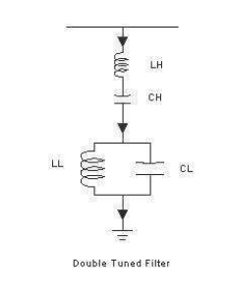
Figure 1 Double Tuned Filter
A double tuned filter is equivalent to two singles tuned filters connected in parallel. These filters use series as well as parallel resonating circuits, which makes it complex. The H ones corresponding to the High Voltages section frequency and the L ones to the Low Voltages.
As we can see, the filter circuit is complex. The component values are finalized only after analysis of impedance vs frequency plots. Adjustment in the component values is made based on the desired filter characteristics.

Advantages

Quality factor the filter is high which gives the greatest attenuation of two harmonics.

Insignificant losses as there is no resistor for damping.

There is only an HV capacitor and reactor because of which it is cheaper than two singles tuned filter connected in parallel.

Disadvantages

The high-Quality factor of the filter gives low bandwidth, which makes filter sensitive to variations in the fundamental frequency as well as the component values.

Accurate tuning is required at the site because of which provision of taps on the reactor is essential. Cost of the reactor raise.

Rating of low voltage component is decided mainly by transient behaviour of the circuit.

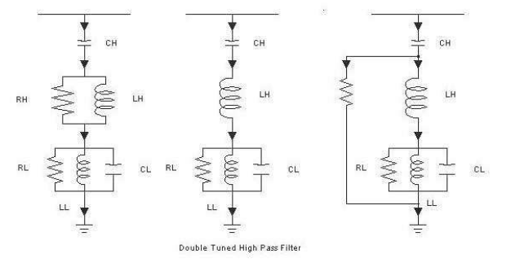
Figure 2 – Double Tuned High Pass Filter
The double tuned highpass filter is similar to the double tuned one. The main difference is the addition of a resistor in parallel. Like the previous filter, H components corresponds to HV section and first tuning frequency, and the L components correspond to LV section and second tuning frequency.

Advantages

The quality factor of the filter is low which makes it effective for a range of harmonics around the first or second tuning frequency. High bandwidth maximum attenuation is obtained for a range of harmonics

There is only an HV capacitor and reactor because of which it is cheaper than two singles tuned filter connected in parallel.

Less sensitive to variation in the fundamental frequency and component values.

Improved filter redundancy.

Disadvantages

It requires larger installed MVAR rating than the first filter give.

Higher losses, because of damping resistor.

Complex filter because of many components.

Additional requirements of protection equipment

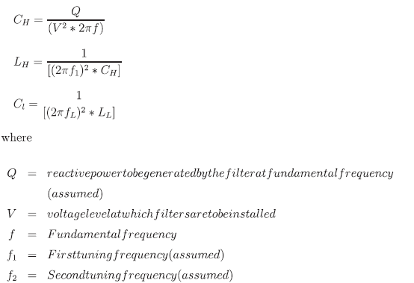
Figure 3 Formules of Passive Power Filter

Third Problem – Active Power Filters
An APF is a filter which can perform an elimination of the harmonics. The big differences between APF and the Passive ones are that Active can mitigate harmonics by injecting active power at the same frequency but with a reverse phase. With that is possible to scratch the harmonic.
Why use APF?
With the many disadvantages of using Passive Filters, such as fixed compensation, large size and resonance problems, that Active Filters were introduced.
Classifications of APF:
- Shunt Active Power Filter
- Series Active Power Filter
- Hybrid Active Power Filters

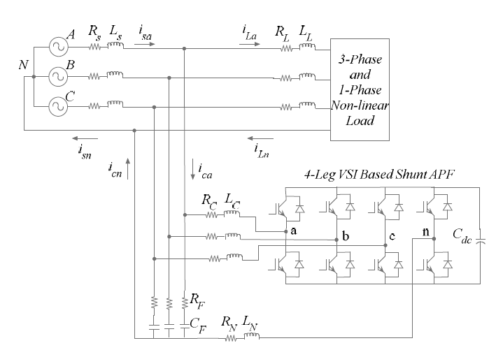
Figure 4 Four-leg configuration of 3-phase 4-wire shunt APF
VSI with IGBT
Voltage Source inverters with Third generation insulated gate bipolar transistors dominate the Low-Voltage adjustable-speed industrial market. The fast rise times of third-generation IGBT’s reduce the package size and, in combination with high-speed digital signal processors, give performance characteristics comparable to dc drives.

Instantaneous Power Theory
Determines the harmonic distortion from the instantaneous power calculation in a three-phase system, which is the multiplication of the instantaneous values of the current and voltages.
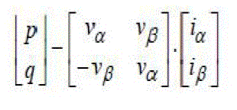
Figure 5 – The calculations
PWM – Pulse Width Modulation
PWM signals is a used to encode the message into a pulse signal. Can be used to control the amount of power delivered to a load without incurring the losses that would result from linear power delivery by resistive means. Is common to use it when wanted to approximate a voltage at the desired level, by switching voltage to the load with a proper level.

Fourth Problem – Thyristor Controlled Reactor
Thyristor-Controlled reactors is a phase controller, which allows the value of delivered reactive power to be adjusted to meet varying system conditions. This Thyristor can be used for limiting voltages of rising on lightly loaded transmission lines. Exist another device, with the same purpose, called MCR – Magnetic Amplifier – as normally denominated as Transductor.

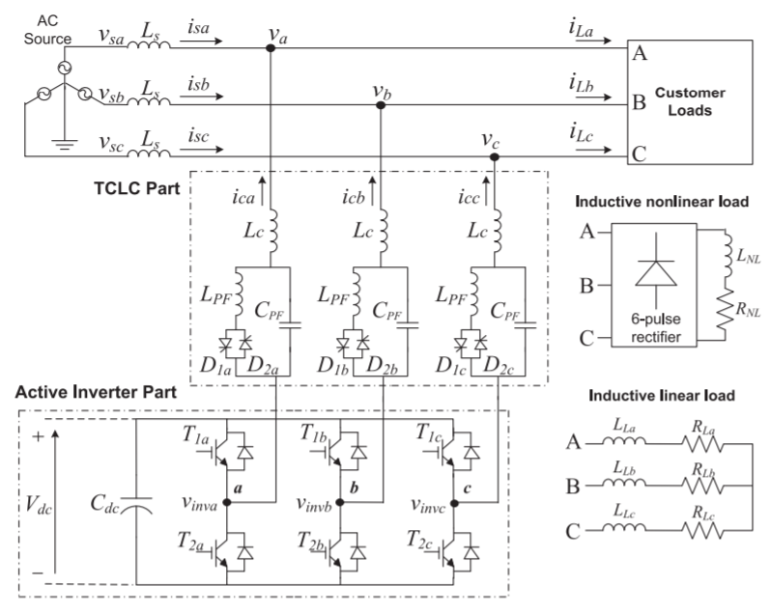
Figure 6 – Circuit Diagram

Conclusion
In this project, I tried my best to understand and study a lot of all the components which are associated with Power Quality. Since Passive until Active Filters, passing throw Thyristors.
In modern electric power systems, there is sharp in the use of single and three phase non-linear loads which causes harmonics disturbances. The main conclusion I can take from this simulations and studies is that Active Power Filters are the emerging devices, which can perform the job of harmonic elimination properly.

Greetings
With my regret and due to the high number of courses having here at the University of Macau, it was difficult to take more time to make a better analysis and finish all the simulations. I apologize for that. It was a really nice pleasure to have this course. I am back to my own University with a better notion of FACTS and DFACTS, and even how it works the Energy in Asia. I am considering, in a few years, after finished my master to start my PhD. I like to make some research and talk about it. Macau will be a big possibility.
Thank you, professor Lam.
References
- J.V. Milanovic and M. Negnesvitsky, “Power Quality Problems and Solutions: current understanding. 8th International Conference on Harmonics and Quality of Power Proceedings. 1998
- Wai-Hei Choi, Chi-Seng Lam, and Man-Chung Wong, “Current Compensation and DC-Link Voltage Control for Current Quality Compensator”, Control and Modeling for Power Electronics (COMPEL), 2012 IEEE 13th Workshop. 2012
- “Understanding Power Quality Problems – Voltage Sags and Interruptions” By John Wiley & Sons; ISBN:0-7803-4713-7
- Jeff Pankau, David Leggate, David W.Sclegel, Russel J. Kerkman and Gary L. Skibinski, “High-Frequency Modeling of Current Sensors”. IEEE TRANSACTIONS ON INDUSTRY APPLICATIONS, VOL. 35, NO. 6, NOVEMBER/DECEMBER 1999
- R. Pregitzer, J. C. Costa, Júlio S. Martins and J. L. Afonso “Simulation and Implementation Results of a 3-Phase 4-Wire Shunt Active Power Filter” ICHQP 2006 Cascais Portugal
- Rashik Tahmid and Shameem Ahmad, “Power Quality Improvement by using Shunt Hybrid Active Power Filter” International Conference on Electrical, Computer and Communication Engineering (ECCE), February 16-18, 2017, Cox’s Bazar, Bangladesh
- Snehal Gadekar, Namrata Kulkarni, Miss.Sheetal Mhetre, Prof.H.H.Kulkarni “Design and Development of Passive Filter and Comparative Study of Simulation Results of Passive and Active Filter” 2015 International Conference on Energy Systems and Applications (ICESA 2015) Dr. D. Y. Patil Institute of Engineering and Technology, Pune, India 30 Oct - 01 Nov 2015
- Sushree Sangita Patnaik, and Anup Kumar Panda, “Optimal Load Compensation by 3-phase 4-wire Shunt Active Power Filter under Distorted Mains Supply Employing Bacterial Foraging Optimization”
- Lei Wang, Chi-Seng Lam and Man-Chung Wong “Hybrid Structure of Static Var Compensator and Hybrid Active Power Filter (SVC//HAPF) for Medium Voltage Heavy Loads Compensation”, IEEE TRANSACTIONS ON INDUSTRIAL ELECTRONICS 2017
- Lei Wang, Chi-Seng Lam and Man-Chung Wong “Unbalanced Control Strategy for AThyristor-Controlled LC-Coupling Hybrid Active Power Filter in Three-Phase Three-Wire Systems“ IEEE TRANSACTIONS ON POWER ELECTRONICS, VOL. 32, NO. 2, FEBRUARY 2017

 

